1. https://github.com/ikonsultandeveloper/Tugas.git

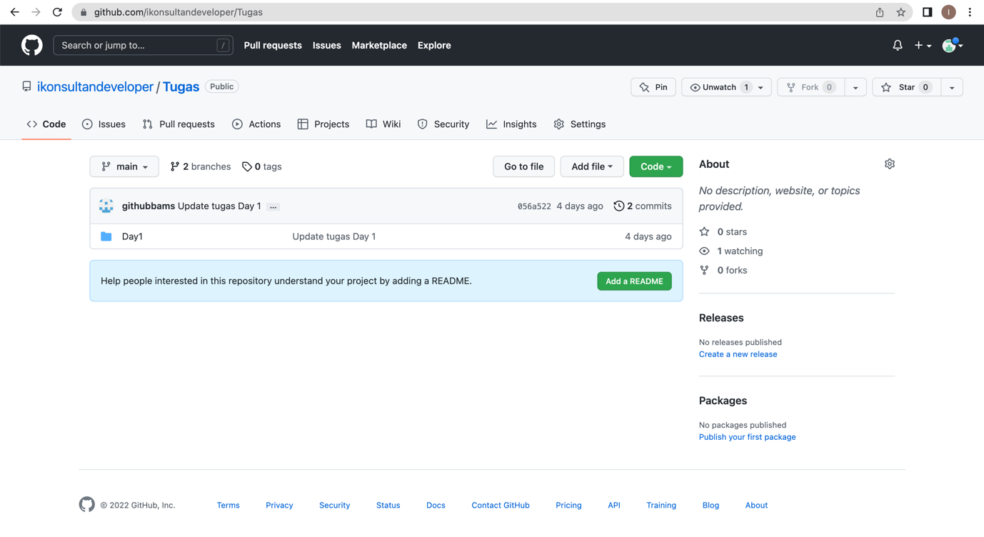

1. a. Create New Branch Development

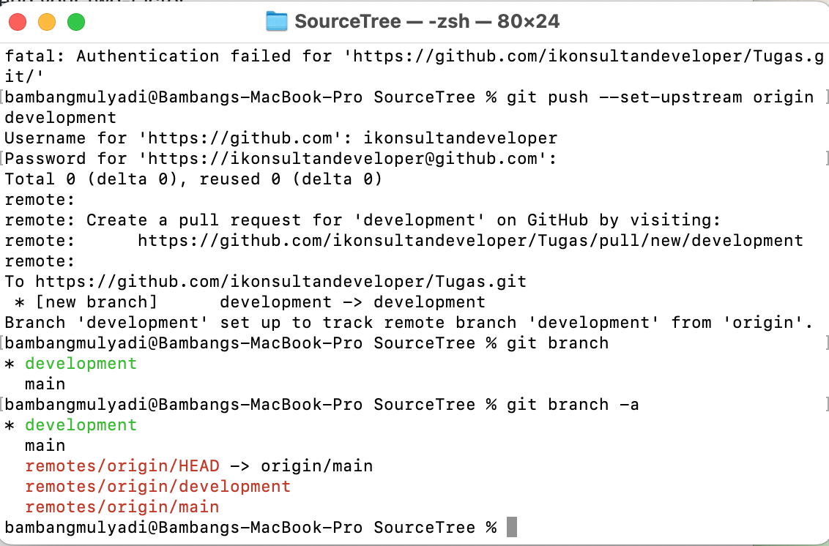

b. Create New Branch FeatureA

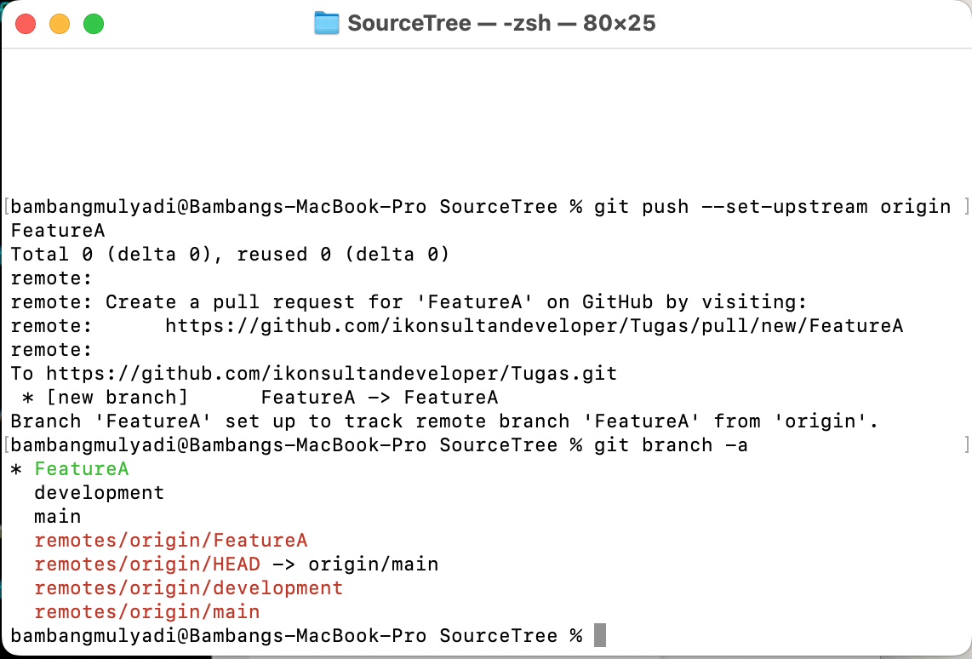

c. Create New Branch FeatureB

